**COMPARATIVE ANALYSIS**

**PAPER 1:** *The Impact of the COVID-19 Pandemic on E-Sports Viewership*

*Trends by James Crone.*

**PAPER 2:** *The Rise of E-SPORTS due to the COVID-19 PANDEMIC by Benjamin Chalson.*

**INTRODUCTION:**

E-Sports is an evolving industry in the online streaming era, streamers saw an huge increase in number of viewers during pandemic which resulted in much higher watch time and enabled them to earn through that with the help of ads and sponsors, viewers also showed great support to the online tournaments which were organized by the streamers, through that tournaments streamers also earned a lot of money and also the winners got a good amount of Prize Money. The Biggest effect of COVID-19 occurred in the Prize Pool Money, which was very less before the pandemic but soon after it surged then also the Prize Pool Money was increased due to the huge number of participants across the globe.

Despite tackling similar themes of viewership and growth within e-sports during COVID-19, the research papers diverge in methodology and specific areas of focus, potentially revealing contrasting findings.

**Paper 1:**

* Focuses on providing a broad overview of E-Sports.
* Explains the history and evolution of E-Sports, from arcade games to online competitions.
* Discusses various game genres within E-Sports and the rise of live streaming.
* Briefly mentions the growing popularity and economic impact of E-Sports.

**Paper 2:**

* Focuses on the specific impact of Covid-19 on E-Sports viewership.
* Identifies research questions to explore how Covid-19 affected and might continue to affect E-Sports.
* Discusses the importance of online gaming communities and platforms like Twitch.tv, Facebook, YouTube etc.
* Plans to analyze viewership trends on Twitch.tv before, during, and after the pandemic using social science theories.

**Now, we will see how the COVID-19 has effected the viewership across different platforms and across different games.** 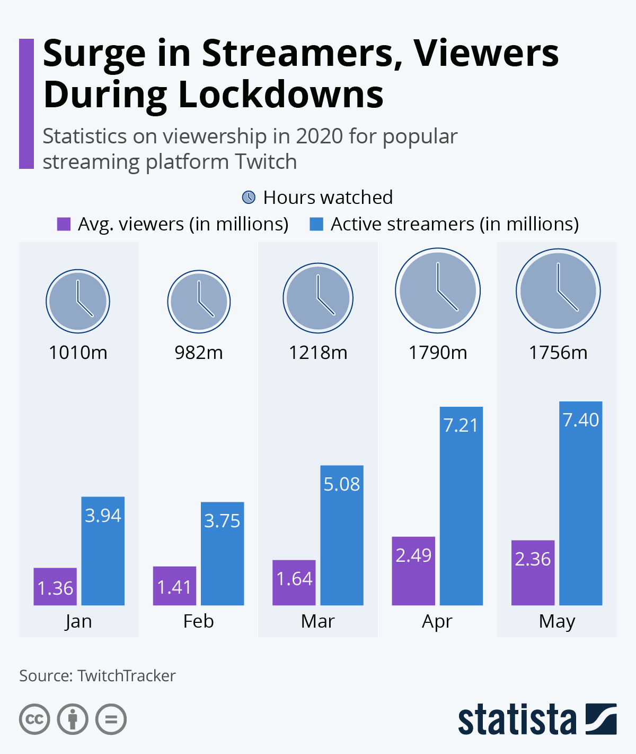

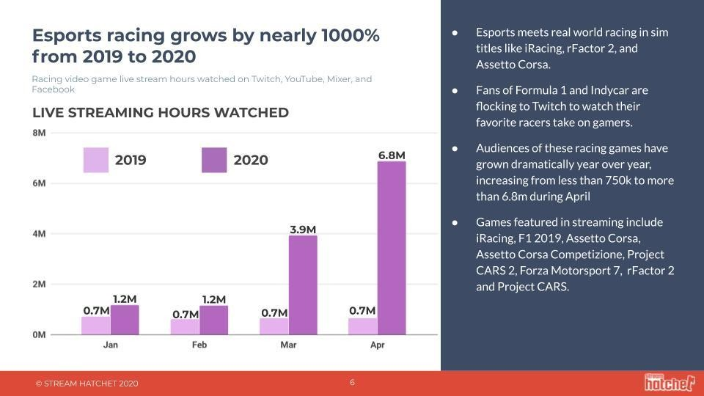

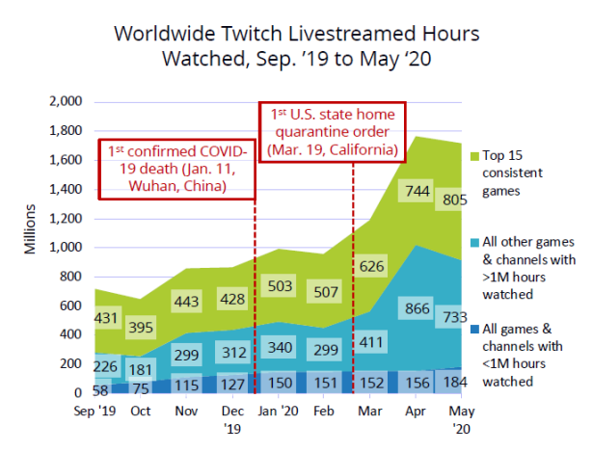

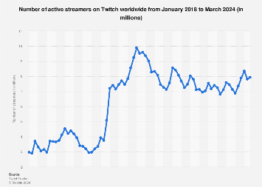  
  
  
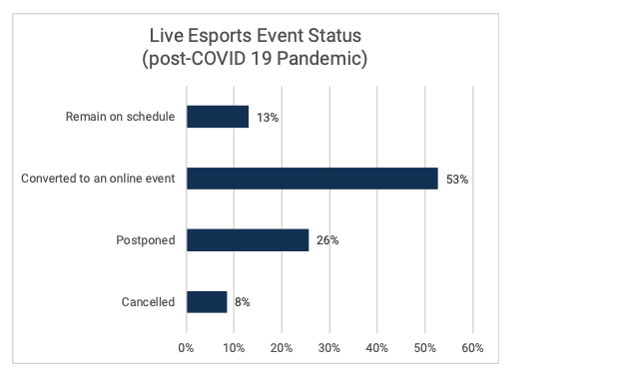

**CONCLUSION:**

Both Papers reflect the impact of COVID-19 on E-Sports community which is growing significantly day by day, the craze of E-Sports grew more when lockdown started and they started to play online games to entertain themselves, resulting in the highest traffic on games servers and highest amount of online streamers and viewers which started earning only because of the E-Sports community.